**Week 4 – Induced Voltage**

Cihan Aydar

**Diametrical Magnetization**

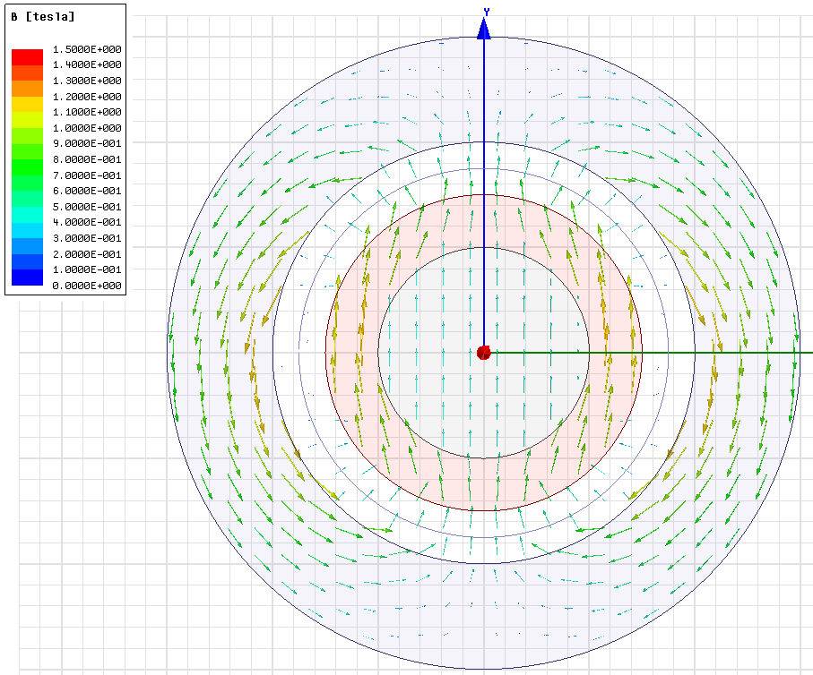

Figure 1 Magnetic Flux Vectors

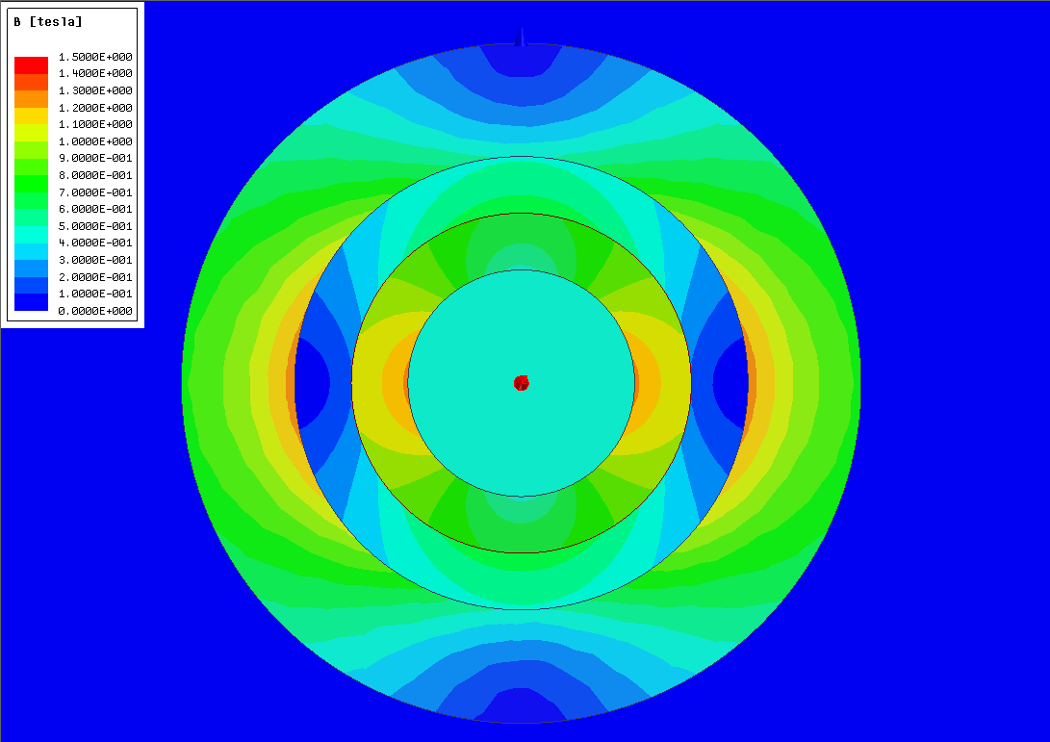

Figure 2 Magnetic Flux Magnitude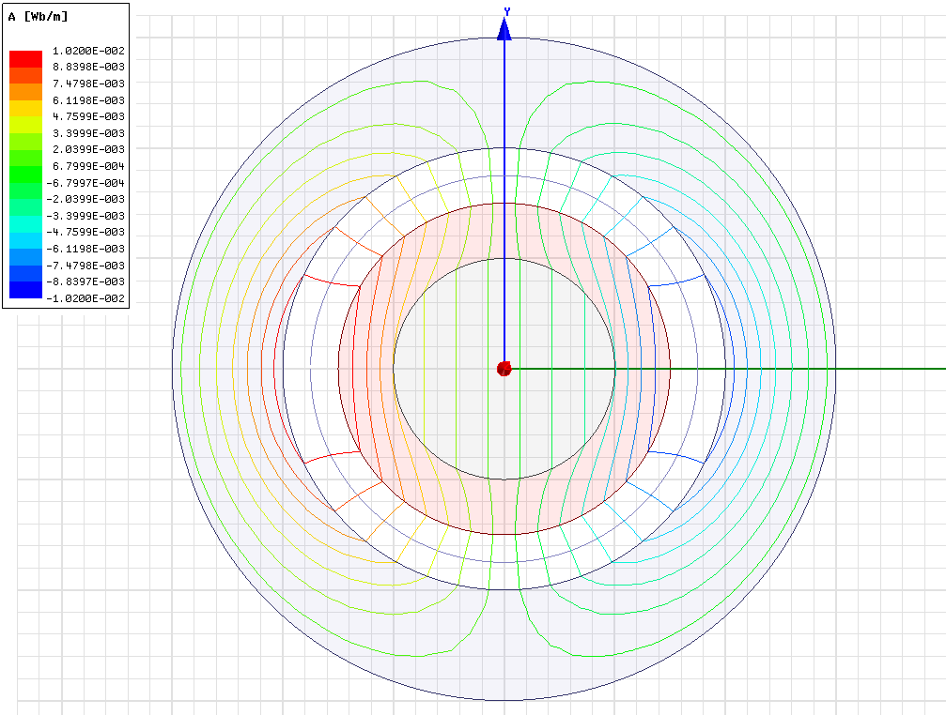

Figure 3 Magnetic Flux Lines

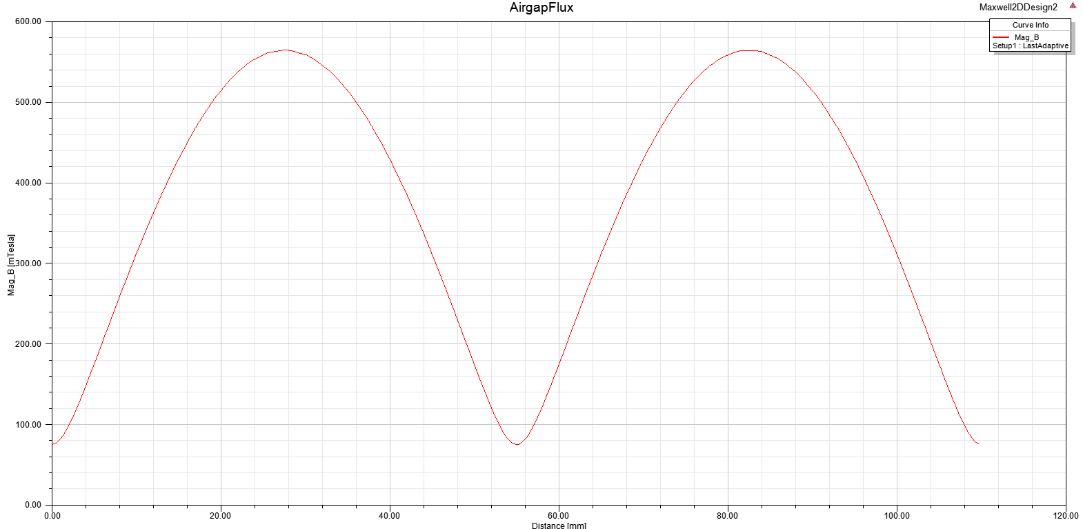

Figure 4 Air Gap Flux Distribution

$$Erms=\frac{1}{\sqrt{2}}.\frac{4.r.l}{π}.Bm.Np.2π.\frac{1500}{60}=\frac{1}{\sqrt{2}}.φ.Np.w=\frac{1}{\sqrt{2}}.2πfNp.φ=\frac{1}{\sqrt{2}}.157.φ at 25Hz (Period=40ms)$$

$$E=N.\frac{dφ}{dt}$$

**Radially Oriented Magnetization**

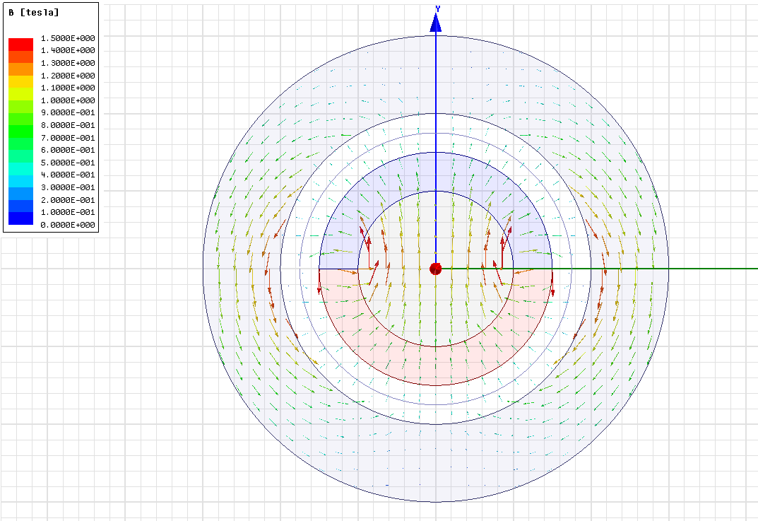

Figure 5 Magnetic Flux Vectors

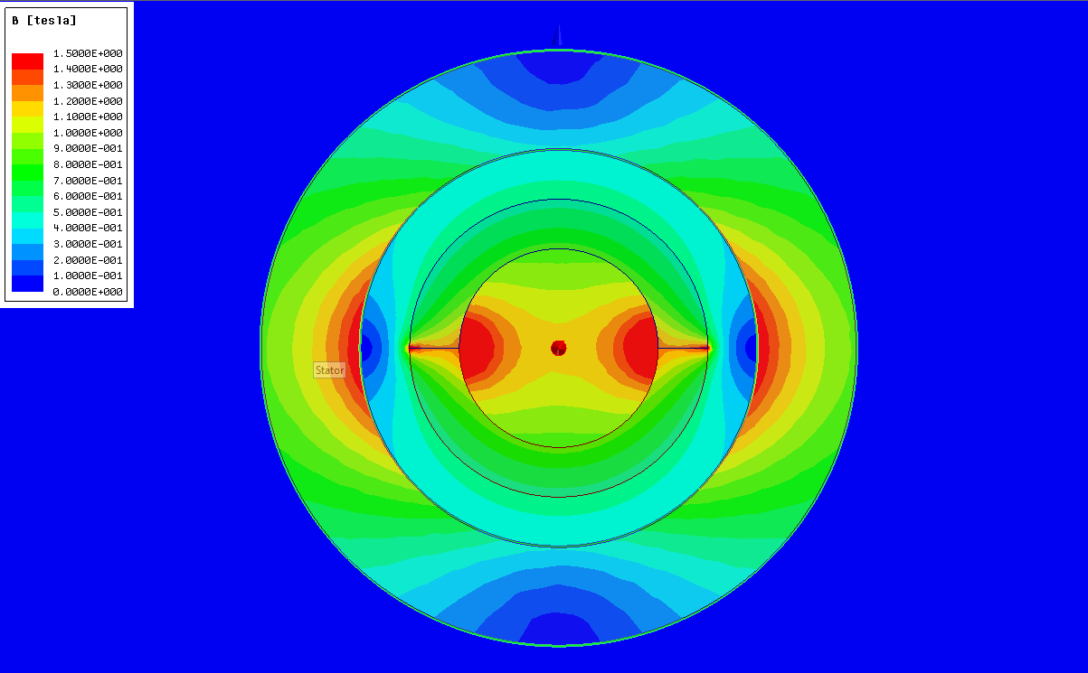*Figure 6 Magnetic Flux Magnitude*

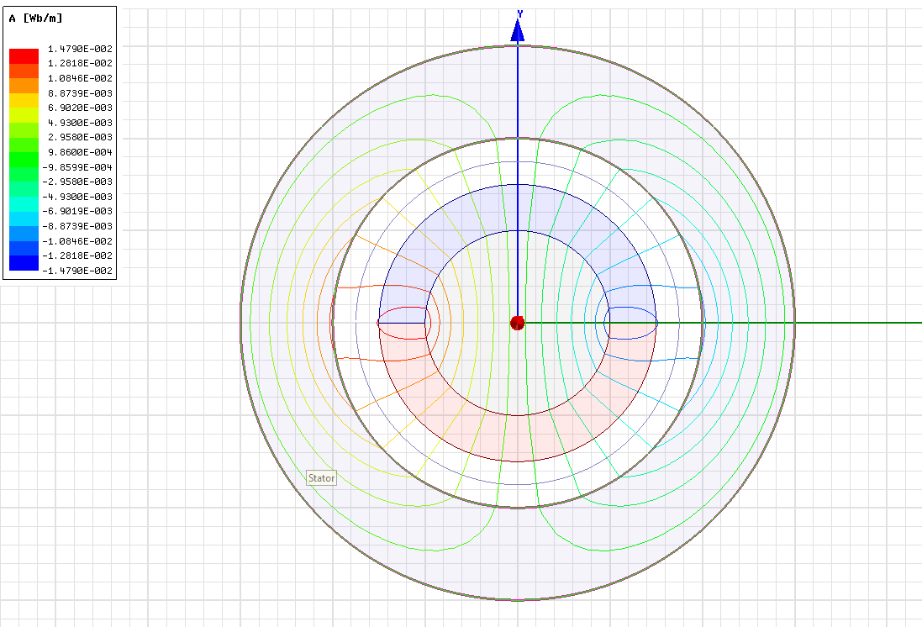

Figure 7 Magnetic Flux Lines

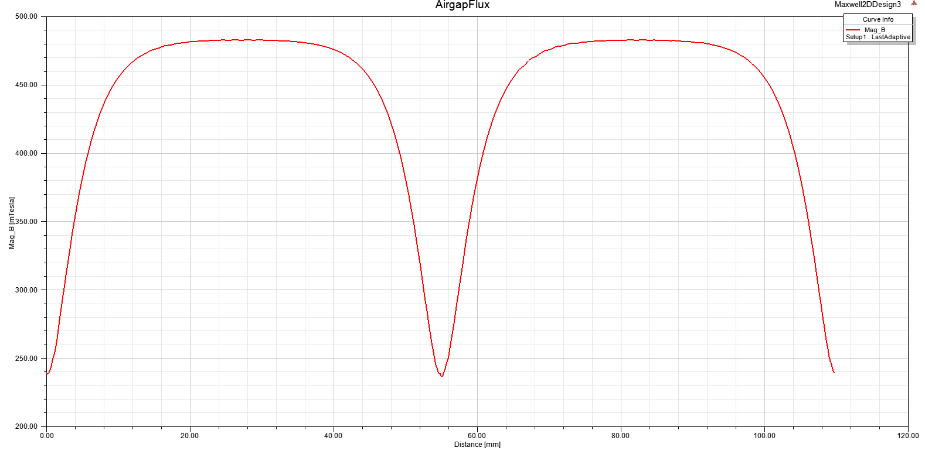

Figure 8 Air Gap Flux Distribution

$$Erms=\frac{1}{\sqrt{2}}.\frac{4.r.l}{π}.Bm.Np.2π.\frac{1500}{60}=\frac{1}{\sqrt{2}}.φ.Np.w=\frac{1}{\sqrt{2}}.2πfNp.φ=\frac{1}{\sqrt{2}}.157.φ at 25Hz (Period=40ms)$$

$$E=N.\frac{dφ}{dt}$$

.